**2025 Scholar Of Tomorrow Economics Essay Contest:**

**How do particular political measurements result in accelerating or impeding indigenous technological innovation in the targeted nation?**

**By Mingyue XU**

**Overseas Family School**

**Abstract**

Amid heightened global technological competition and geopolitical tensions, policy interventions such as sanctions, trade conflicts, tariffs, and industrial strategies exert substantial influence on domestic innovation outcomes in affected economies by redirecting resource allocation The World Trade Organization highlighted in its research report titled "The Impact of Geopolitical Conflicts on Trade, Growth and Innovation" that trade barriers significantly impede the flow of goods and hinder sanctioned countries from accessing advanced cross-border technologies and innovative ideas.(WTO). Protectionism, to a large extent, weakens the technological integration capacity of the target country. Fortunately, some countries have become self-reliant in the face of technological barriers.In the Science, Technology and Innovation Policy Review conducted by the United Nations Conference on Trade and Development (UNCTAD), the report on Iran highlights that, in response to severe international sanctions imposed by certain countries, there has been a notable impetus for the development of science, technology, and innovation (STI). Furthermore, countries facing sanctions are likely to foster the establishment of localized innovation systems and knowledge-based economies. For example, Iran has experienced what can be termed "crisis-driven innovation" as a result of these pressures.(UNCTAD). This paper aims to employ a combination of quantitative and qualitative methods to conduct an in-depth analysis of the impact of sanctions and industrial policies on domestic technological innovation in targeted countries.

**Historical context**

The theory of international trade is grounded in the principle of comparative advantage, which posits that countries should specialize in the production of goods with lower opportunity costs. This specialization enables nations to realize gains from trade and fosters global economic growth.

Empirical research indicates that when a country implements political trade interventions, the market mechanism is frequently distorted. This form of protectionism may induce a trade diversion effect, leading to a decline in global productivity and resulting in a dual loss of economic efficiency and innovation capacity for all parties involved.From 1949 to 1991, the United States imposed strict export controls on high-tech products to the Soviet Union, especially from the 1950s to the 1970s (U.S. Department of State). This policy was implemented by the United States and led by its Allies, using high-tech export control embargoes as a means to restrict reliance on microelectronics and production capacity. A report by the official Central Intelligence Agency (CIA) of the United States indicates that the lack of Western production technology has led to a reduction of up to 25% in the annual output of microelectronic products in the discrete semiconductor field in the Soviet Union. （CIA） In the report from 1979 to 1983, the Office of Technology Assessment (OTA) and the Government Accountability Report of the U.S. Congress highlighted the economic costs, relationship friction and implementation difficulties associated with export controls.（Office of Technology Assessment）Apart from the Soviet Union being restrained by innovation, the United States and its Allies bear the economic burden of trade restrictions. It was one of the key reasons for suspending sanctions policies in the 1990s.

**Market Restructuring under EU Sanctions**

**Trade protection policies, including export restrictions and technical barriers, can impede the entry of international products into the target country's market. The resultant reduction in the number of market competitors, coupled with an increase in market concentration, has facilitated the emergence of a monopolistic structure within the target country. This has led to the target country shifting from a market structure that is close to perfect competition to an oligopoly or a state-owned monopoly. In a monopolistic competition market, a firm maximizes profits at the output where marginal revenue (MR) equals marginal cost (MC). If average revenue (AR) exceeds average cost (AC) at this point, the firm earns abnormal profits,  by provide the funds to support R&D and innovation activities.（Avinash K. Dixit and Joseph E. Stiglitz）**

Due to Iran’s nuclear program and ongoing human rights disputes, the European Union has intensified sanctions since 2010. These measures include restrictions on oil exports, freezing of central bank assets, and a ban on the export of high-technology energy equipment to Iran, such as deep-sea drilling technology, liquefied natural gas (LNG) technology, and refining equipment. The severity of these sanctions is exemplified by the EU's comprehensive oil embargo that took effect in 2012, which resulted in a dramatic decline in Iran’s fiscal revenue by over $400 billion annually (Council of the European Union). The EU's withdrawal from the Iranian market has led to a short-term increase in market concentration among Iranian companies. In a monopolistic market structure, long-term equilibrium occurs when price exceeds marginal cost (P > MC), leading to deadweight loss (DWL). Due to insufficient competitive pressure, monopoly firms often struggle to achieve minimum production costs (min ATC). Furthermore, lax regulation coupled with government subsidies can result in X-inefficiency within firms. Consequently, this situation compelled Iran to develop domestic capabilities for refining and natural gas liquefaction. Between 2017 and 2019, Iran successfully completed the Persian Gulf Star Refinery (PGSR), recognized as the world’s first condensate refinery entirely designed and constructed domestically. As illustrated in Figure 1, significant advancements have been made by Iran in artificial intelligence research; Iranian academic institutions are actively exploring AI further to foster innovation (Insikt Group). Scientific research indicates that Iran has emerged as one of the leading nations in nanotechnology research, with several technologies now entering commercial application markets.

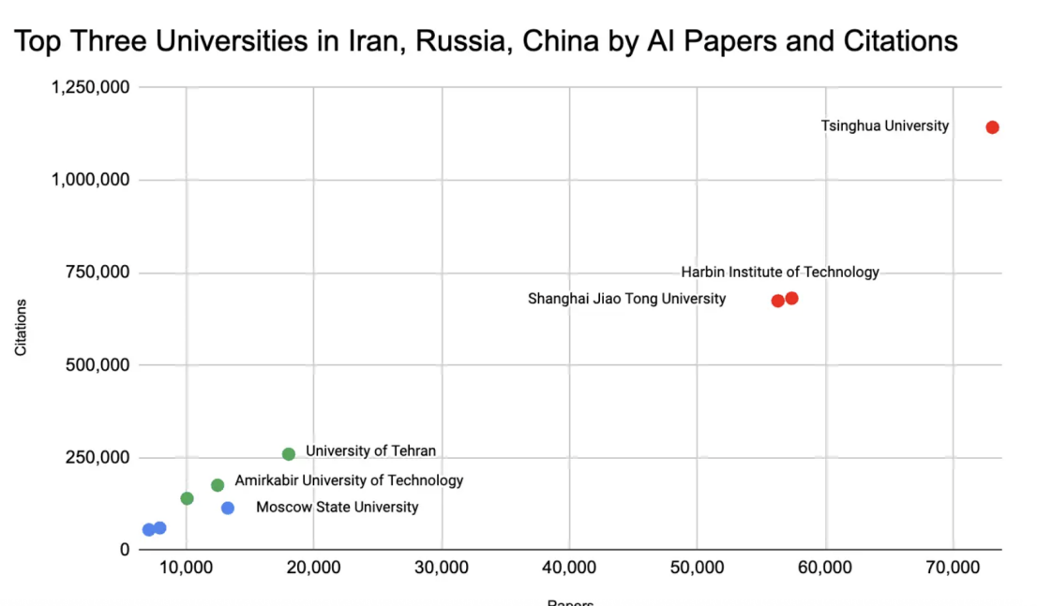

Figure 1, the top three universities in Iran, Russia, and China by papers and citations of AI.

**Tariff Barriers and Sanctions: Constraints on Capital Deepening and Technological Innovation**

Tariff policies exert a significant inhibitory effect on capital deepening (Sergii Meleshchuk and Yannick Timmer). When a country imposes tariffs on high-tech capital goods, such as advanced machinery and equipment, precision instruments, and AI chips, the resultant increase in import prices leads to elevated investment costs for businesses. This situation complicates their ability to import these essential goods. Given that high-tech capital goods are often non-substitutable, domestic industries face challenges in providing equivalent alternatives in the short term. Consequently, businesses may be compelled to reduce their purchases or even prohibit the use of such technologies altogether (Alexander Knobel and Alexander Firanchuk). The direct consequence of these developments is a decline in gross capital formation within national accounts, which subsequently hampers the accumulation of capital stock. This impeded process of capital deepening can significantly decelerate innovation rates, ultimately manifesting as a slowdown in economic growth. The observed decrease in the movement of the PPC and LRAS curves further substantiates the negative impact that international trade barriers impose on potential innovation growth.

In response to the ongoing conflict in Ukraine, the United States has implemented a new series of sanctions that prohibit the export of high-performance AI models, similar to GPT, as well as related IT services, such as cloud-based design software and consulting services, to Russia (Harry Clark). As figure 2 , the accompanying graph illustrates a significant increase in the number of new sanctions imposed on Russia by the United States and its allies since the onset of the Russia-Ukraine conflict (Russia Faces Thousands of Active Sanctions). Furthermore, GigaChat's Russian-language model is ranked 8th on LLM Arena, whereas its English-language counterpart did not even secure a position within the top 170 (Mia Jankowicz and Thibault Spirlet).

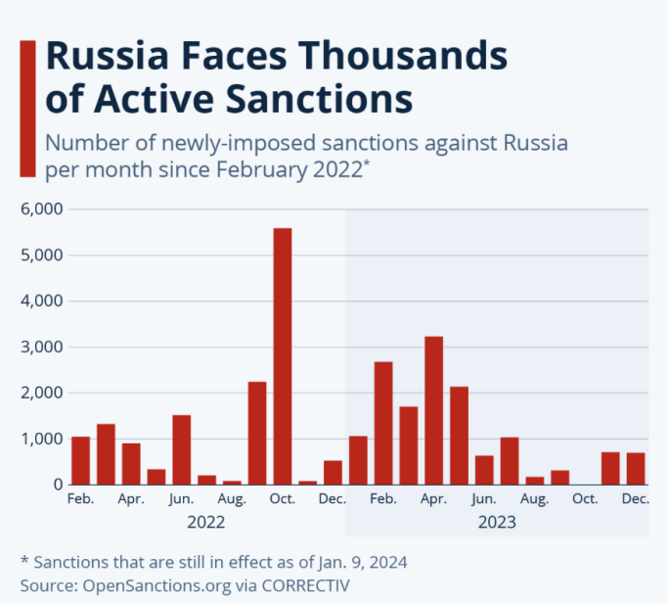

Figure 2， Russia faces thousand of active sanctions

In the realm of high-precision code generation and algorithm optimization, GPT-4, powered by Codex, demonstrates the ability to produce efficient cross-language code while also offering automatic debugging capabilities. In contrast, GigaChat's coding functionalities are limited due to its lack of extensive training on large-scale open-source code. Technological blockades and sanctions have significantly hindered the advancement of Russian enterprises in the field of artificial intelligence, resulting in a diminished competitiveness within the global market.

**Policy Recommendations: Strengthening Domestic Innovation and Refining Sanctions**

Target countries should enhance their domestic innovation ecosystems. Corporate law should incorporate regulations concerning retained earnings, specifically the establishment of an “excess profit reinvestment obligation,” which mandates that protected companies allocate a certain percentage of their profits towards research and development (R&D) and talent development (Vikki Velasquez). This approach leverages monopoly profits to foster innovation.

Imposing countries should focus on political measures by reducing “indiscriminate” sanctions and tariffs, transitioning to the principle of minimum necessary constraints, and targeting only those technologies and industries that are directly related to national security.

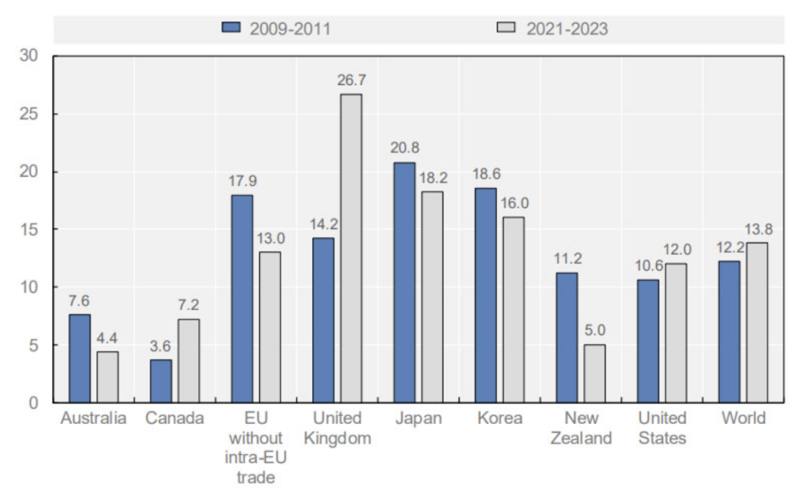

Figure 3, Countries facing significantly more numerous export restrictions on their imports of raw materials.

The figure illustrates that certain countries are experiencing a significantly higher incidence of export restrictions on imports and raw materials (Figure 3 ).

The OECD has reported that export restrictions on critical raw materials have surged more than fivefold in recent years, with a particularly pronounced concentration observed between 2021 and 2023 (OECD). This escalation has contributed to rising global production costs and heightened investment uncertainty, thereby undermining worldwide economic growth and adversely affecting the countries imposing these restrictions. Consequently, it is recommended that a "negative list security assessment cycle" be established to facilitate regular reviews of the necessity for sanctions and tariffs.

**Conclusion**

Political measures accelerate or hinder the target country’s independent technological innovation in domestic industrial policies changes（Juhász, Réka, and Nathan Lane）. In the short term, policies such as sanctions can, in a reverse way, promote the independent innovation and resource development of the target countries. However, in the long term, protectionism will impede technological exchanges among countries, which will also lead to a reduction in global trade and a slowdown in the growth rate of the global economy.

**Reference**

1.Clark, Harry. *New Export Controls on Advanced Computing Items and AI Model Weights.* Orrick, Herrington & Sutcliffe LLP, 27 Jan. 2025.

2.Council of the European Union. “EU Sanctions against Iran.” *Consilium.europa.eu*, Council of the EU, accessed 23 Aug. 2025,<https://www.consilium.europa.eu/en/policies/sanctions-against-iran/?utm_source=chatgpt.com>.

3.Dixit, Avinash K., and Joseph E. Stiglitz. "Monopolistic competition and optimum product diversity." *The American Economic Review* 67.3 (1977): 297-308.

4.Goes, Carlos, and Eddy Bekkers. *The Impact of Geopolitical Conflicts on Trade, Growth, and Innovation.* WTO Economic Research and Statistics Division, June 2022, [www.wto.org/english/res_e/reser_e/ersd202209_e.htm](http://www.wto.org/english/res_e/reser_e/ersd202209_e.htm?utm_source=chatgpt.com).

5.Hinrich Foundation. “OECD Inventory of Export Restrictions on Industrial Raw Materials 2025 | How to Use It | Hinrich Foundation.” 24 June 2025, [www.hinrichfoundation.com/research/how-to-use-it/inventory-of-export-restrictions-on-industrial-raw-materials-2025/?utm_source](http://www.hinrichfoundation.com/research/how-to-use-it/inventory-of-export-restrictions-on-industrial-raw-materials-2025/?utm_source=chatgpt.com). Accessed 29 Aug. 2025.

6.Jankowicz, Mia, and Thibault Spirlet. "While the US and China Compete for AI Dominance, Russia's Leading Model Lags Behind." *Business Insider*, 7 Mar. 2025.

7.Juhász, Réka, and Nathan Lane. “A New Economics of Industrial Policy.” *Finance & Development*, June 2024, www.imf.org/en/Publications/fandd/issues/2024/06/A-New-Economics-of-Industrial-Policy-Reka-Juhász-and-Nathan-Lane.

8.Meleshchuk, Sergii, and Yannick Timmer. “Are Capital Goods Tariffs Different?” *IMF Working Papers*, no. 2020/061, International Monetary Fund, May 2020, [https://doi.org/10.5089/9781513545271.001](https://doi.org/10.5089/9781513545271.001?utm_source=chatgpt.com). Accessed 15 Aug. 2025.

9.Memorandum From the Chairman of the Inter-Agency Task Force To Review the COCOM System (Armstrong) to the Chairman of the National Security Council Under Secretaries Committee (Irwin). *Foreign Relations of the United States, 1969–1976, Volume IV, Foreign Assistance, International Development, Trade Policies, 1969–1972, Document 383,* Washington, 20 Nov. 1972. Office of the Historian, U.S. Department of State, history.state.gov.

10.nsikt Group. *Iran’s AI Ambitions: Balancing Economic Isolation with National Security Imperatives.* Recorded Future, 16 April 2025, recordedfuture.com/research/irans-ai-ambitions-balancing-economic-isolation-national-security-imperatives.

11.Office of Technology Assessment. *Technology and East-West Trade.* Washington, D.C.: U.S. Government Printing Office, Nov. 1979. Library of Congress Catalog Card Number 79-600203. Stock No. 052-003-00723-1. OTA Report. PDF file.

12.Organisation for Economic-Cooperation and Development. *Export Restrictions on Critical Raw Materials Rise Sharply Amid Growing Demand.* OECD, 12 May 2025, [www.oecd.org/en/about/news/press-releases/2025/05/export-restrictions-on-critical-raw-materials-rise-sharply-amid-growing-demand.html](http://www.oecd.org/en/about/news/press-releases/2025/05/export-restrictions-on-critical-raw-materials-rise-sharply-amid-growing-demand.html?utm_source=chatgpt.com).

13.Pandey, Ruchika, Prabhat Singh, Raymond Wei, and Shaila Shankar. “Transforming Software Development: Evaluating the Efficiency and Challenges of GitHub Copilot in Real-World Projects.” *arXiv*, 13 June 2024, [https://arxiv.org/pdf/2406.17910](https://arxiv.org/pdf/2406.17910?utm_source=chatgpt.com).

14.Reuters. “Iran Turns to Gasoline Exports after Sanctions Hit Oil Sales.” *Reuters*, [https://www.reuters.com/article/iran-gasoline/iran-turns-to-gasoline-exports-after-sanctions-hit-oil-sales-idUSL5N25Y2SY](https://www.reuters.com/article/iran-gasoline/iran-turns-to-gasoline-exports-after-sanctions-hit-oil-sales-idUSL5N25Y2SY?utm_source=chatgpt.com)?.

15.Statista. “Russia Faces Thousands of Active Sanctions – Number of Newly-Imposed Sanctions Against Russia per Month Since February 2022.” *Statista*, published Jan. 12, 2024, [https://www.statista.com/chart/31560/newly-imposed-sanctions-against-russia-per-month/](https://www.statista.com/chart/31560/newly-imposed-sanctions-against-russia-per-month/?utm_source=chatgpt.com).

16.“SOVIET MICROELECTRONICS: IMPACT OF WESTERN TECHNOLOGY ACQUISITIONS.” SW86-10062, Central Intelligence Agency, December 1986, [https://www.cia.gov/readingroom/docs/DOC_0000499603.pdf](https://www.cia.gov/readingroom/docs/DOC_0000499603.pdf?utm_source=chatgpt.com). Accessed 17 Aug. 2025.

17.UNCTAD. *Science, Technology and Innovation Policy Review: Iran.* United Nations Conference on Trade and Development, 2022, unctad.org/es/node/27202.

18.Velasquez, Vikki. “Retained Earnings in Accounting and What They Can Tell You.” *Investopedia*, 21 Jul. 2004, [www.investopedia.com/terms/r/retainedearnings.asp](http://www.investopedia.com/terms/r/retainedearnings.asp?utm_source=chatgpt.com).